LS-LSTER :
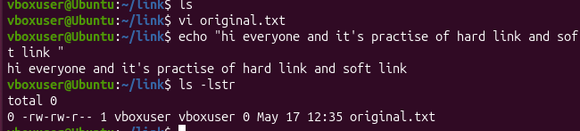

HARD LINK :
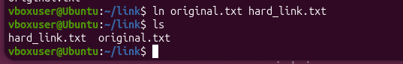
LS-LSTR:
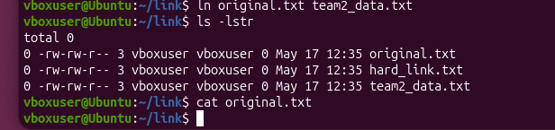

SOFT LINK :
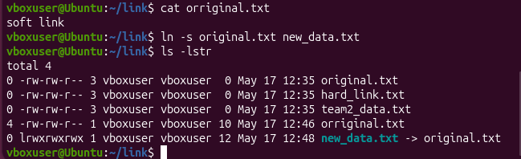
NOHUP AND TOP :
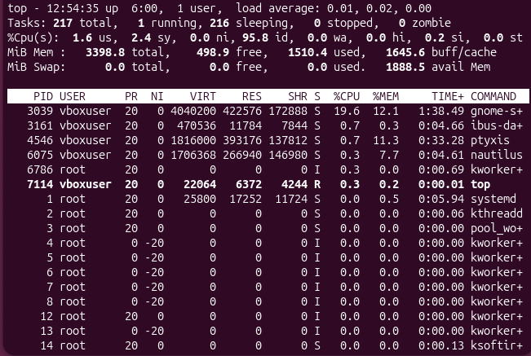
WILL SHOW THE BACKGROUND PROCESS RUNNING
PS:
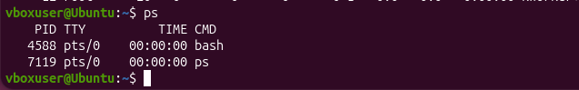

PS – AUX :
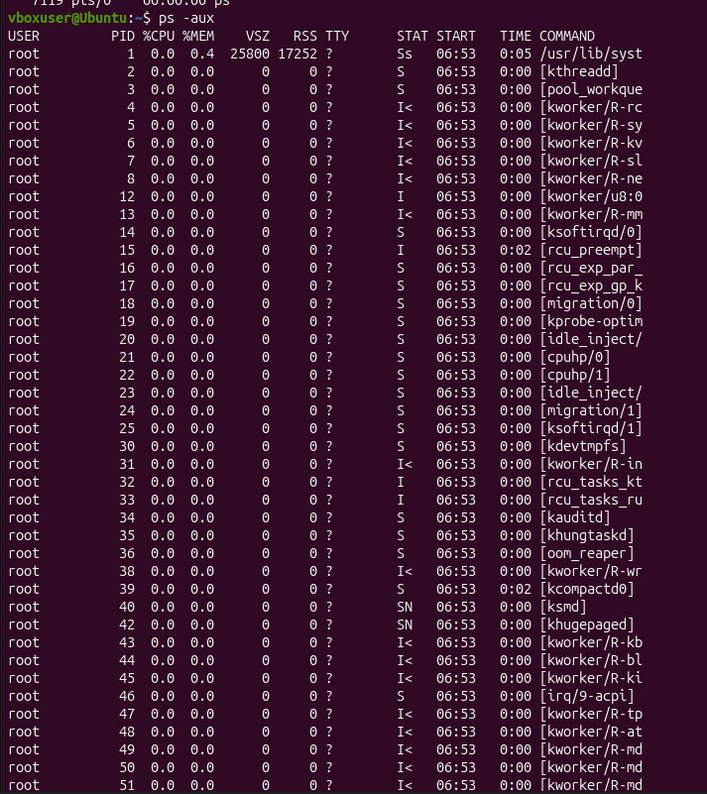
KILL:
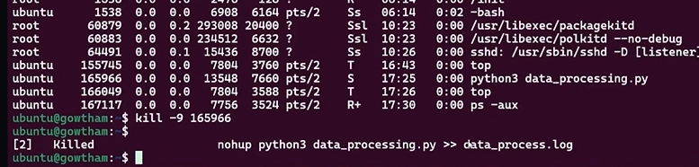

PS -AUX |GREP FILE NAME :
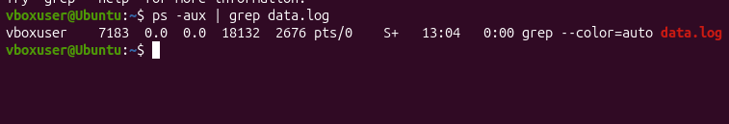
DOWNLOAD FILE :
